[](http://www.comsol.com/)

Untitled

Report date

Apr 18, 2025 11:50:12 AM

Contents

1. Global Definitions

1.1. Parameters 1

2. Component 1

2.1. Definitions

2.2. Geometry 1

2.3. Materials

2.4. Solid Mechanics

2.5. Electrostatics

2.6. Electrical Circuit

2.7. Multiphysics

2.8. Mesh 1

3. Study 1

3.1. Parametric Sweep

3.2. Stationary

4. Results

4.1. Data Sets

4.2. Plot Groups

1. Global Definitions

|  |  |
| --- | --- |
| Date | Apr 14, 2025 11:29:56 AM |

Global settings

|  |  |
| --- | --- |
| Name | PEG analysis.mph |
| Path | C:\Users\saite\Documents\PEG analysis.mph |
| COMSOL version | COMSOL 5.2a (Build: 152) |

Used products

|  |
| --- |
| COMSOL Multiphysics |
| CAD Import Module |
| MEMS Module |

* 1. Parameters 1

Parameters

| **Name** | **Expression** | **Value** | **Description** |
| --- | --- | --- | --- |
| R_load | 12[kohm] | 12000 Ω | load resistance |
| acc | 1 | 1 | acceleration |

1. Component 1
   1. Definitions
      1. Coordinate Systems

#### Boundary System 1

|  |  |
| --- | --- |
| Coordinate system type | Boundary system |
| Tag | sys1 |

* 1. Geometry 1

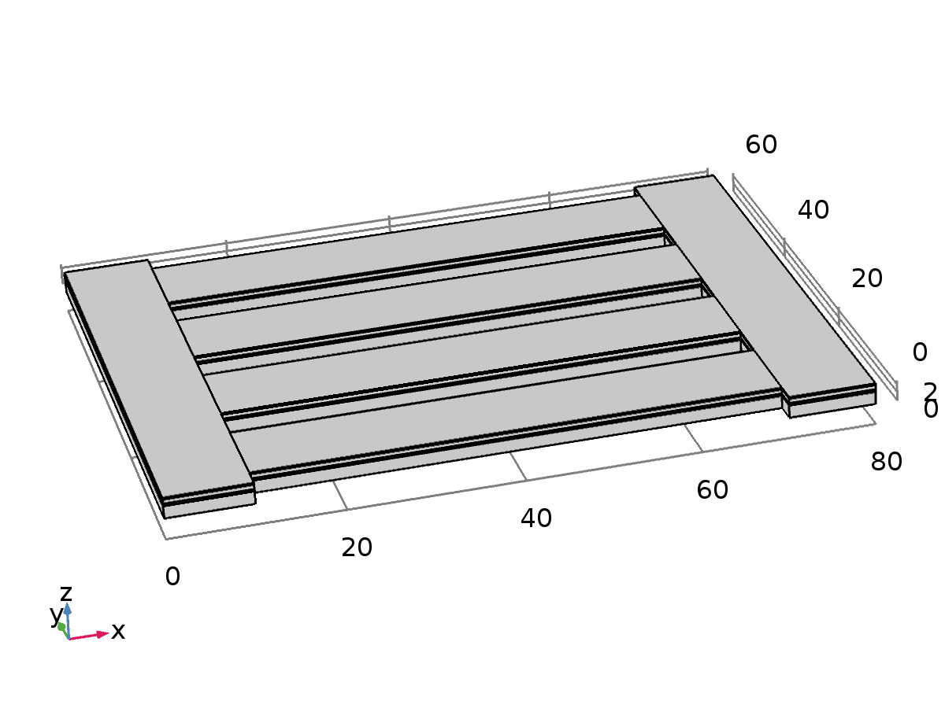

Geometry 1

Units

|  |  |
| --- | --- |
| Length unit | µm |
| Angular unit | deg |

* 1. Materials
     1. Si - Polycrystalline Silicon

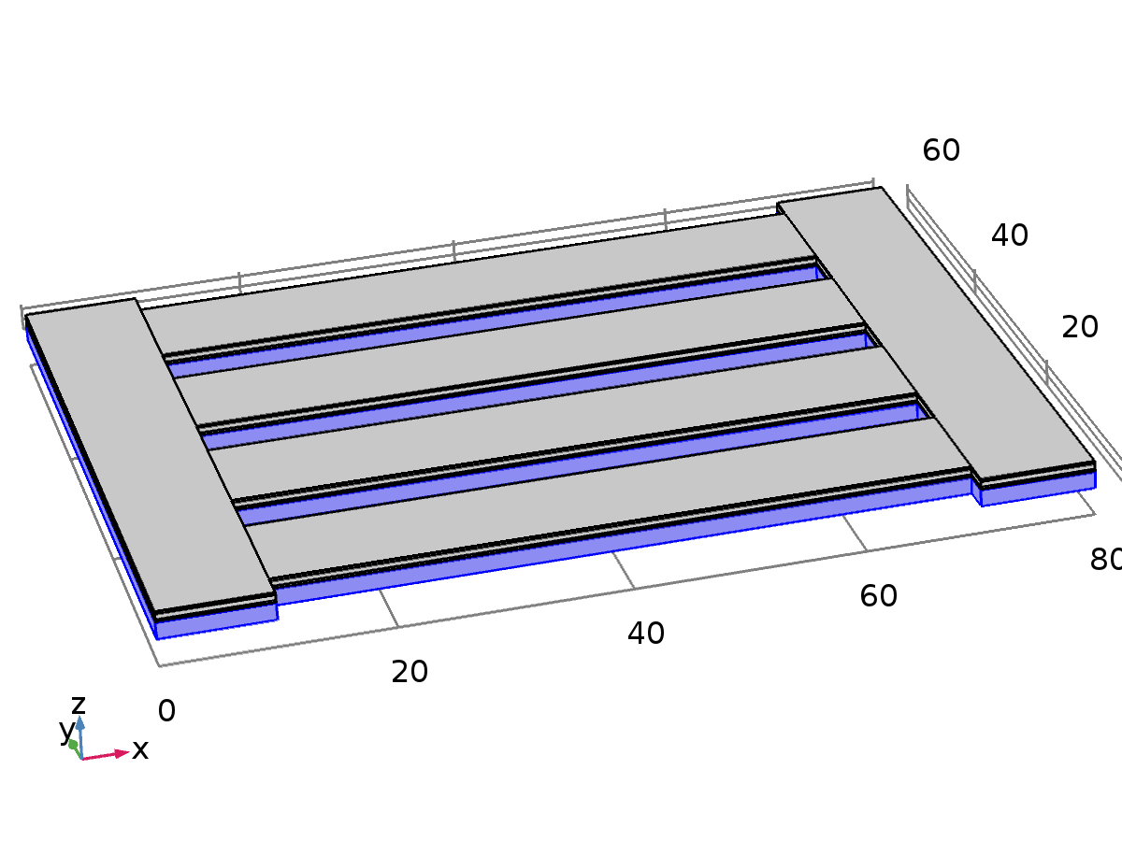

Si - Polycrystalline Silicon

Selection

|  |  |
| --- | --- |
| Geometric entity level | Domain |
| Selection | Domains 1, 6, 11, 16, 21, 26 |

* + 1. Au - Gold

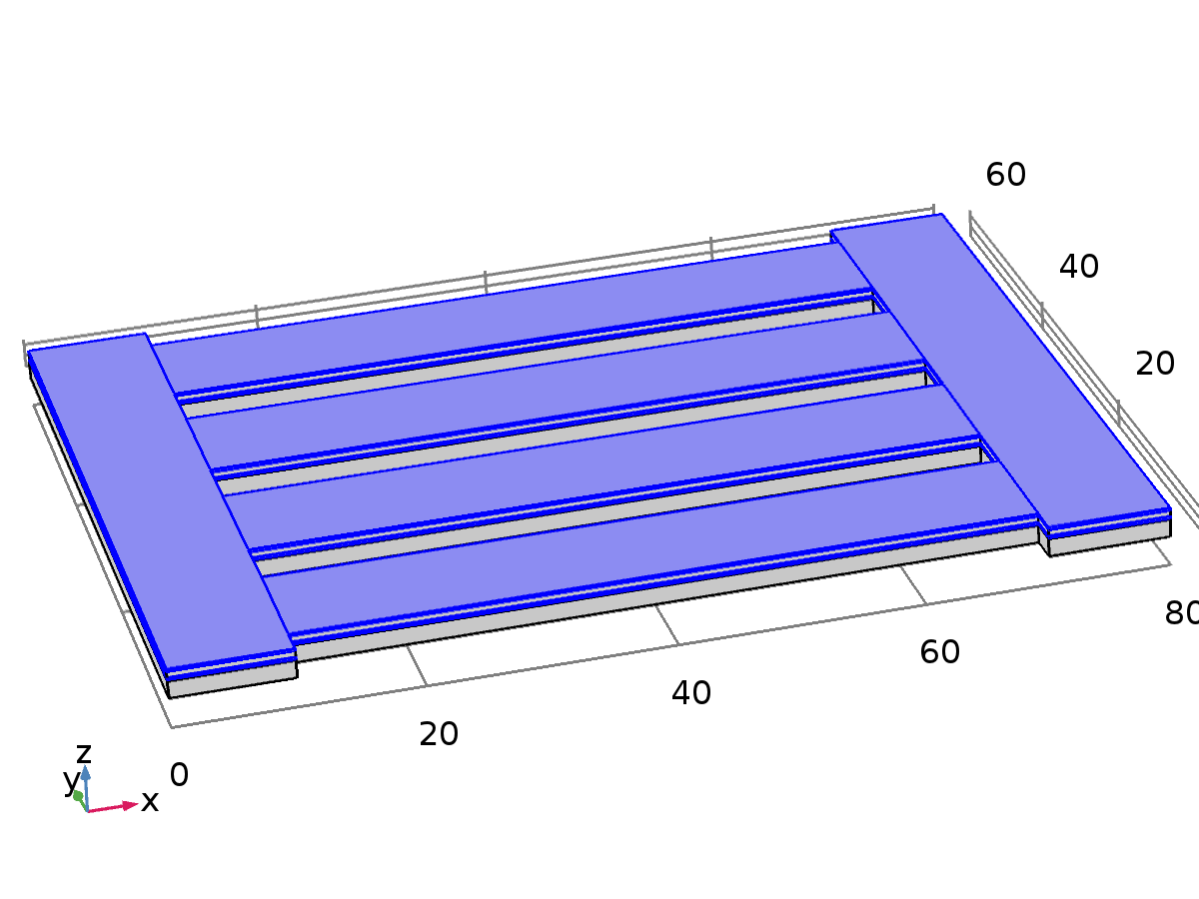

Au - Gold

Selection

|  |  |
| --- | --- |
| Geometric entity level | Domain |
| Selection | Domains 3, 5, 8, 10, 13, 15, 18, 20, 23, 25, 28, 30 |

* + 1. SiO2 - Silicon oxide

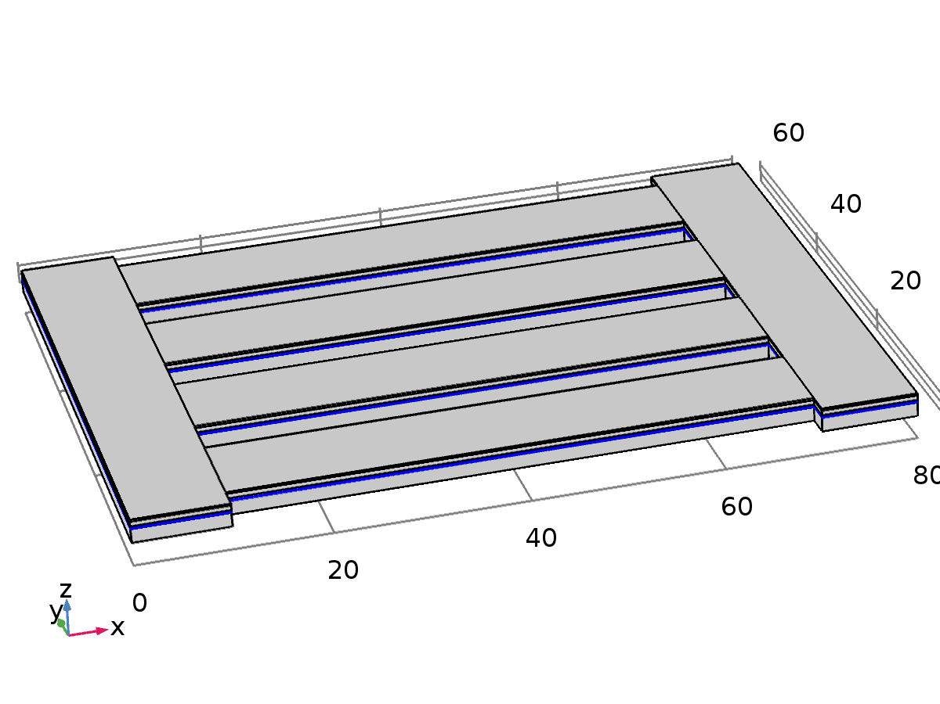

SiO2 - Silicon oxide

Selection

|  |  |
| --- | --- |
| Geometric entity level | Domain |
| Selection | Domains 2, 7, 12, 17, 22, 27 |

* + 1. Lead Zirconate Titanate (PZT-5H)

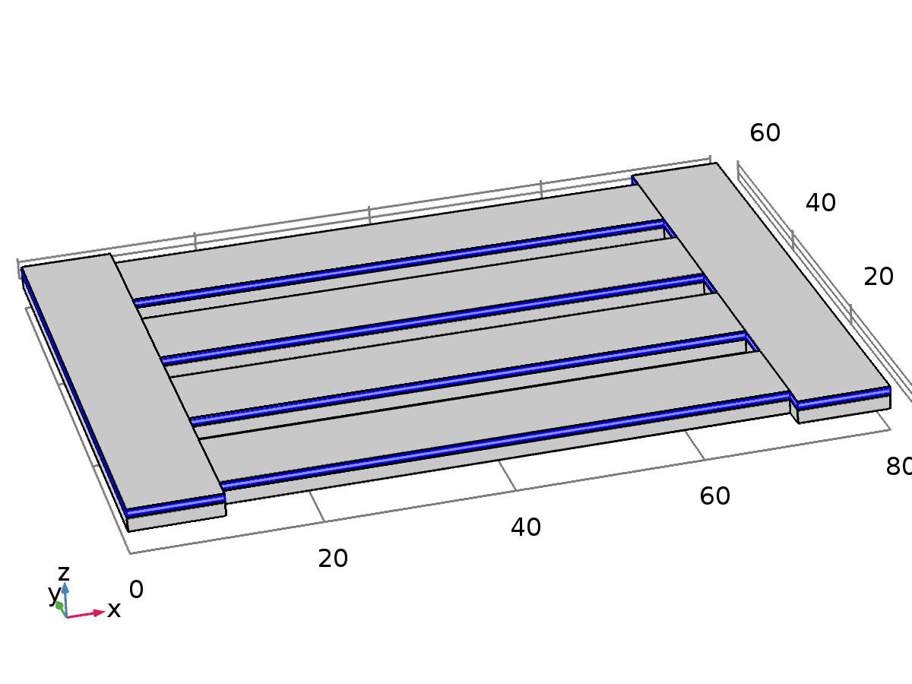

Lead Zirconate Titanate (PZT-5H)

Selection

|  |  |
| --- | --- |
| Geometric entity level | Domain |
| Selection | Domains 4, 9, 14, 19, 24, 29 |

* 1. Solid Mechanics

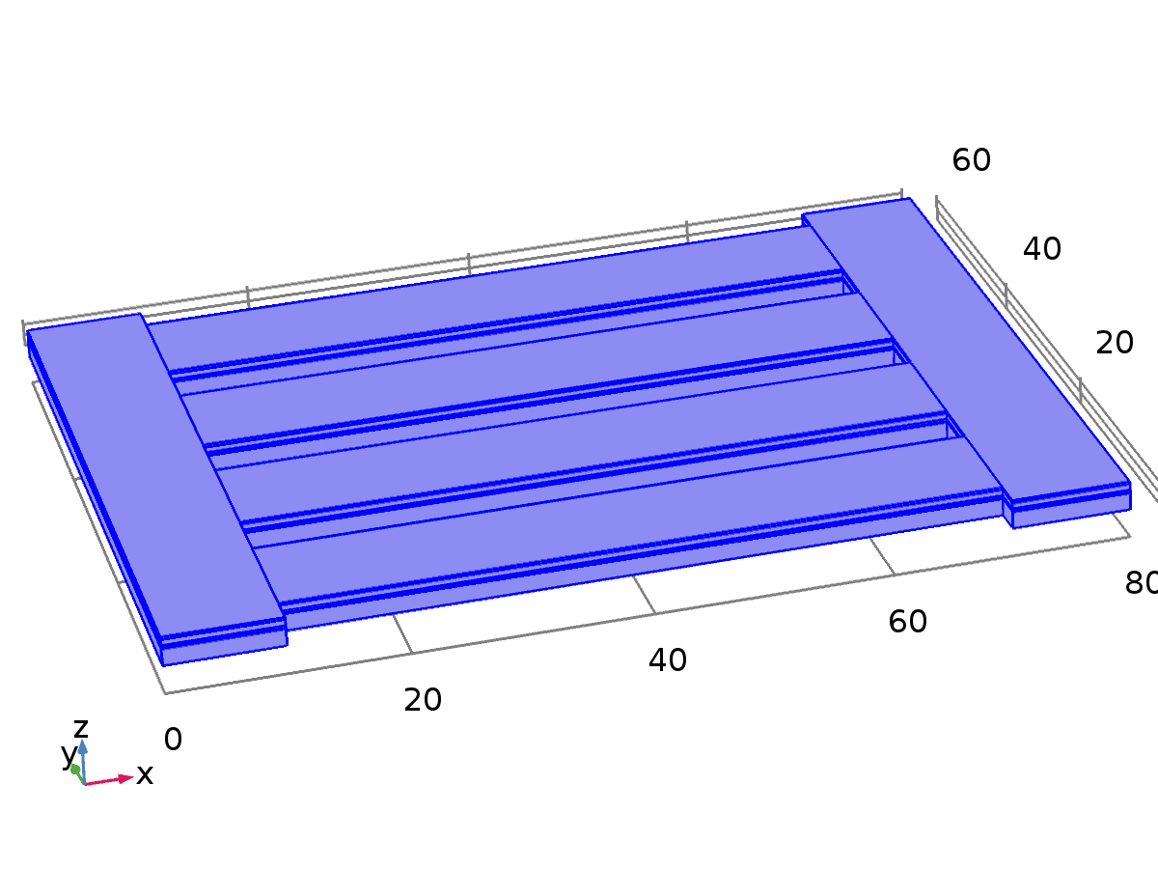

Solid Mechanics

Equations



Features

|  |
| --- |
| Linear Elastic Material 1 |
| Free 1 |
| Initial Values 1 |
| Piezoelectric Material 1 |
| Fixed Constraint 1 |
| Body Load 1 |

* + 1. Linear Elastic Material 1

Equations











* + 1. Piezoelectric Material 1

Equations















* + 1. Fixed Constraint 1

Equations



* + 1. Body Load 1

Equations



* 1. Electrostatics



Electrostatics

Equations





Features

|  |
| --- |
| Charge Conservation 1 |
| Zero Charge 1 |
| Initial Values 1 |
| Charge Conservation, Piezoelectric 1 |
| Terminal 1 |
| Ground 1 |

* + 1. Charge Conservation 1

Equations





* + 1. Zero Charge 1

Equations



* + 1. Charge Conservation, Piezoelectric 1

Equations





* + 1. Terminal 1

Equations



* + 1. Ground 1

Equations



* 1. Electrical Circuit

Equations

Features

|  |
| --- |
| Ground Node 1 |
| External I-Terminal 1 |
| Resistor 1 |

* 1. Multiphysics
     1. Piezoelectric Effect 1



Piezoelectric Effect 1

* 1. Mesh 1

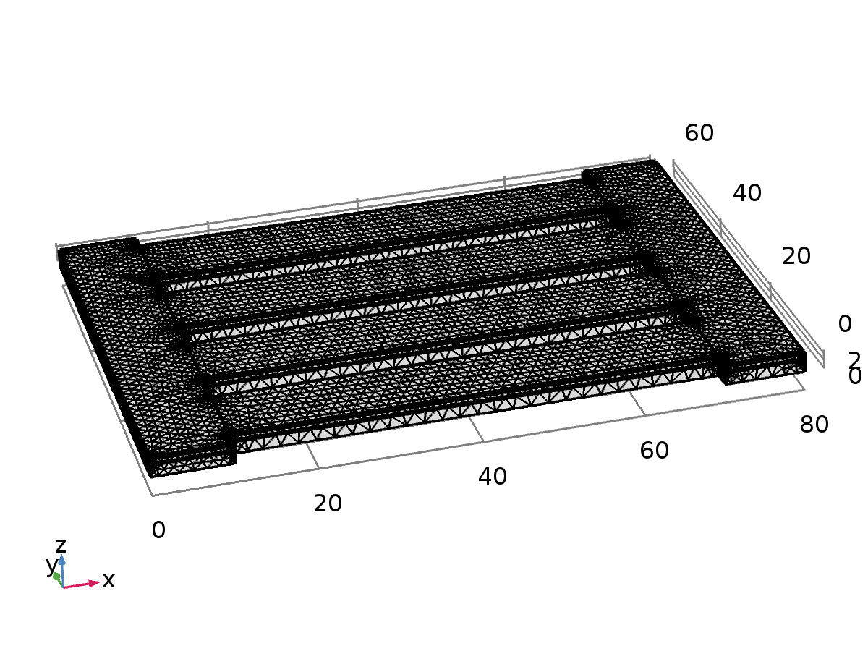

Mesh 1

1. Study 1

Computation information

|  |  |
| --- | --- |
| Computation time | 8 min 29 s |
| CPU | 12th Gen Intel(R) Core(TM) i5-1240P, 16 cores |
| Operating system | Windows 10 |

* 1. Parametric Sweep

| **Parameter name** | **Parameter value list** |
| --- | --- |
| R_load | range(1,1,5) |

* 1. Stationary

Study settings

| **Description** | **Value** |
| --- | --- |
| Include geometric nonlinearity | Off |

Physics and variables selection

| **Physics interface** | **Discretization** |
| --- | --- |
| Solid Mechanics (solid) | physics |
| Electrostatics (es) | physics |
| Electrical Circuit (cir) | physics |

Mesh selection

| **Geometry** | **Mesh** |
| --- | --- |
| Geometry 1 (geom1) | mesh1 |

1. Results
   1. Data Sets
      1. Study 1/Solution 1

Solution

| **Description** | **Value** |
| --- | --- |
| Solution | Solution 1 |
| Component | Save Point Geometry 1 |

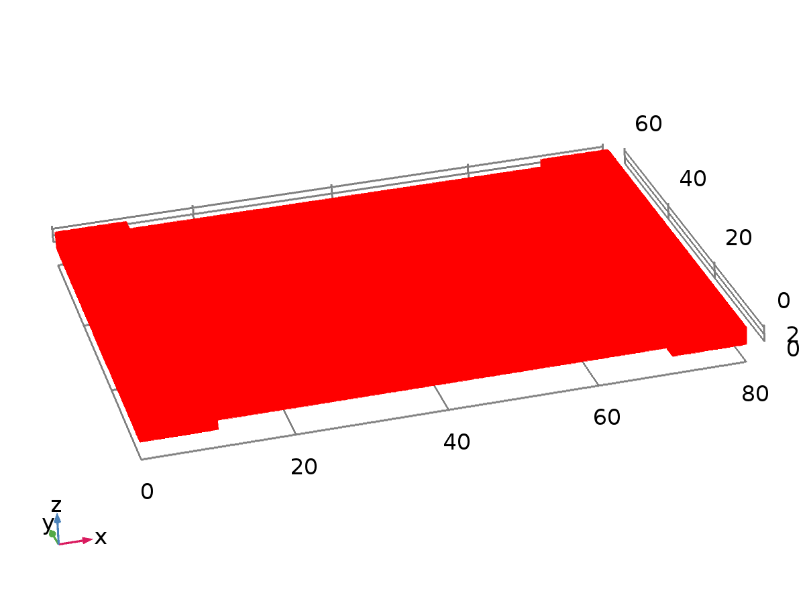

Data set: Study 1/Solution 1

* + 1. Study 1/Parametric Solutions 1

Solution

| **Description** | **Value** |
| --- | --- |
| Solution | Parametric Solutions 1 |
| Component | Save Point Geometry 1 |



Data set: Study 1/Parametric Solutions 1

* 1. Plot Groups
     1. Stress (solid)

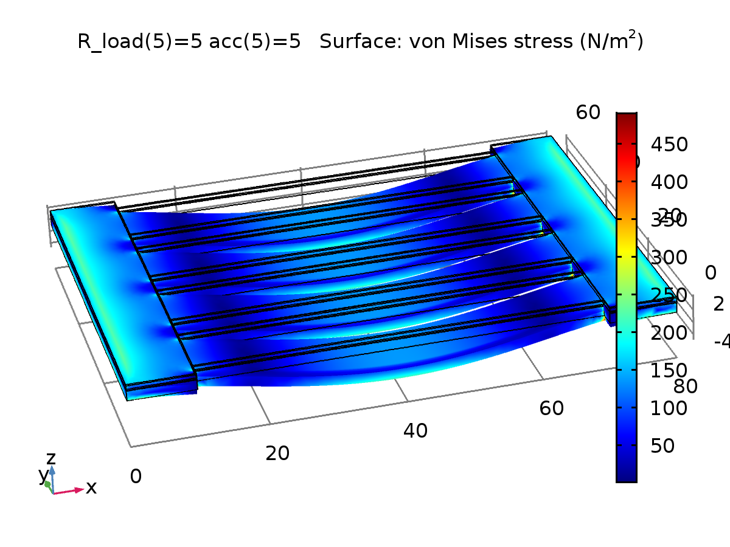

R_load(5)=5 acc(5)=5 Surface: von Mises stress (N/m2)

* + 1. Electric Potential (es)

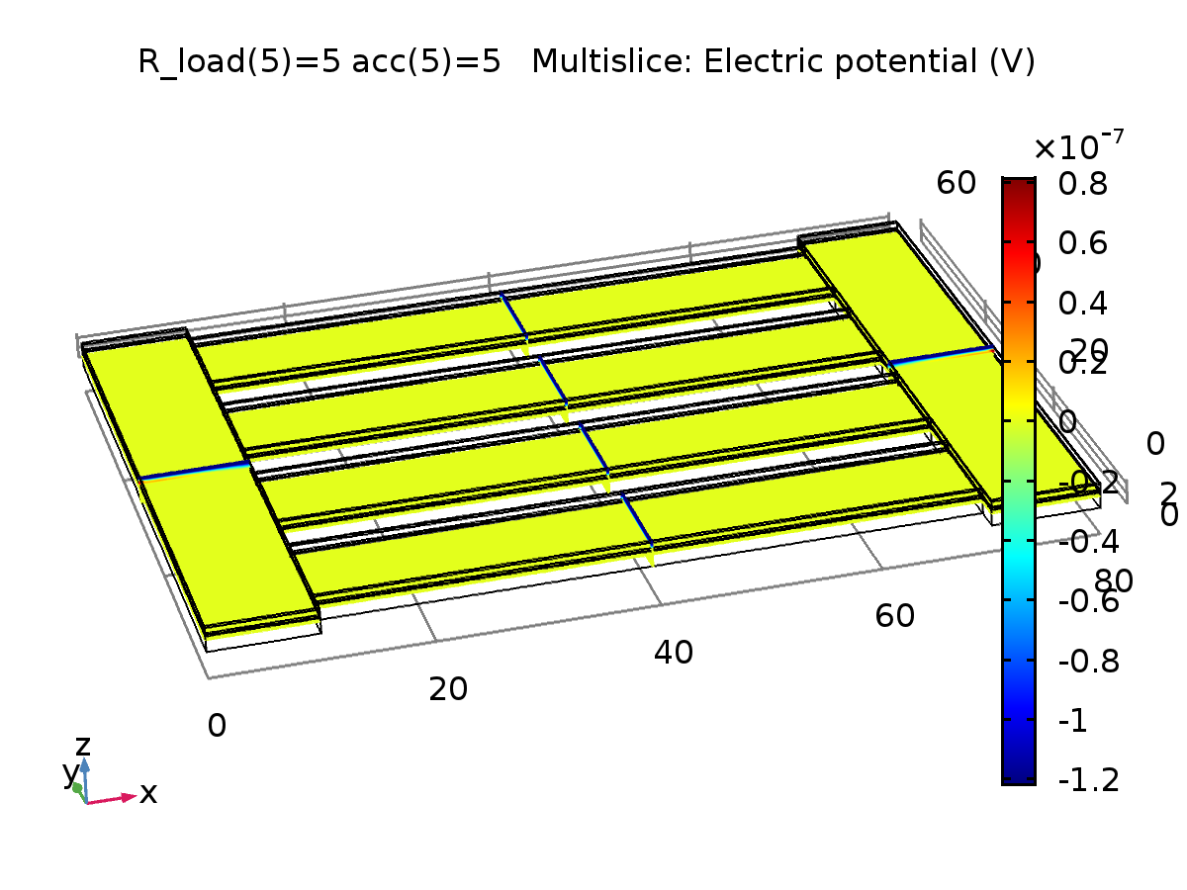

R_load(5)=5 acc(5)=5 Multislice: Electric potential (V)

* + 1. Displacement

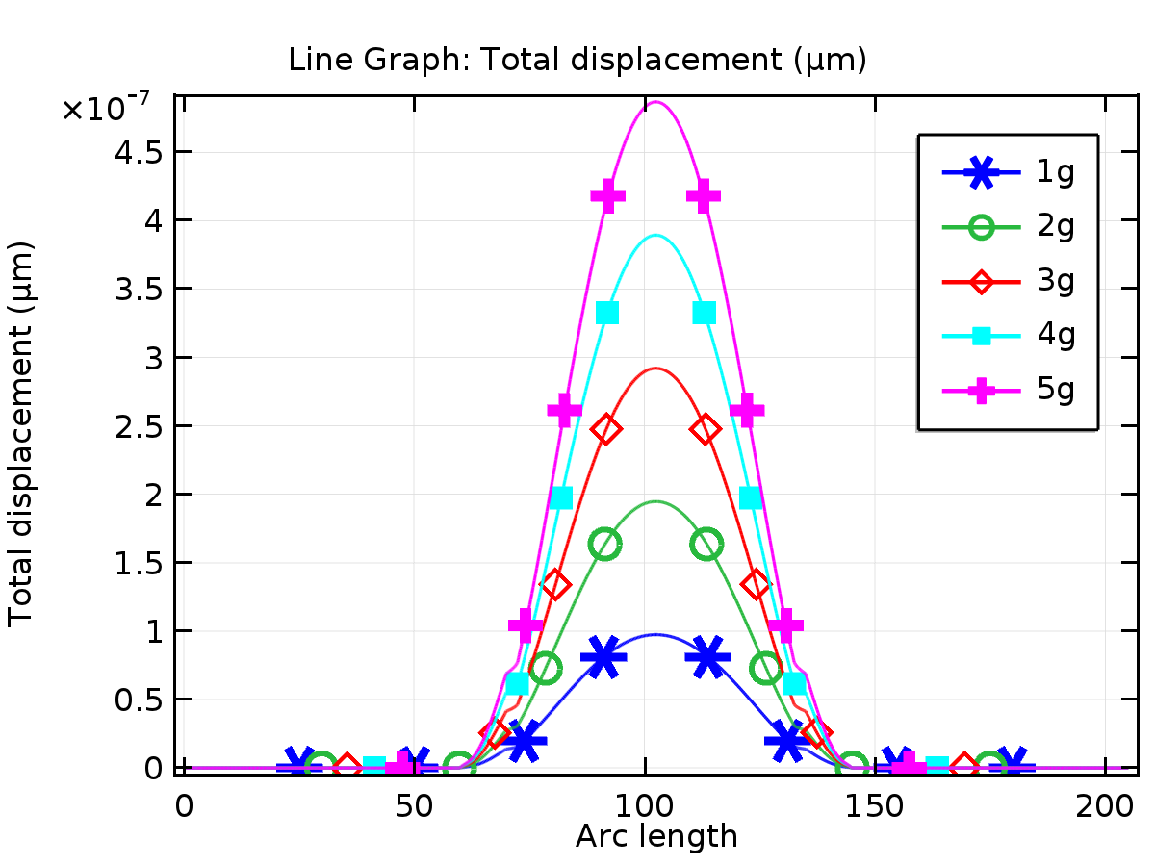

Line Graph: Total displacement (µm)

* + 1. Stress

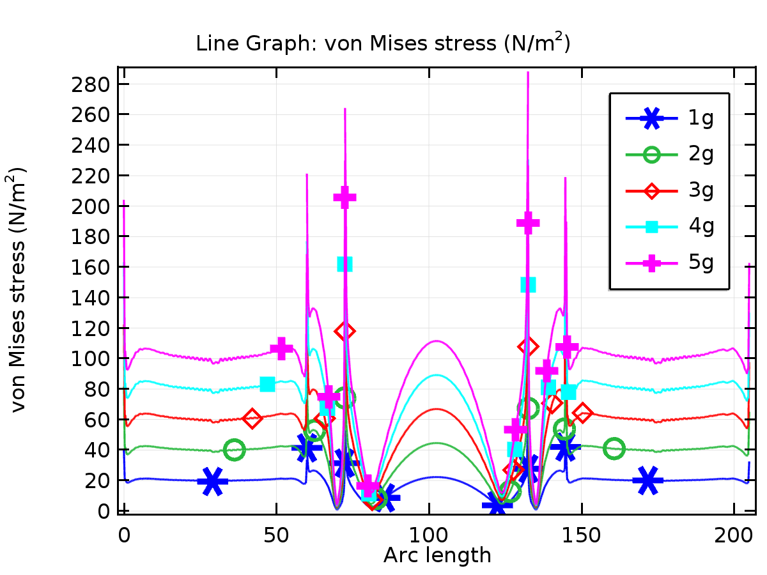

Line Graph: von Mises stress (N/m2)

* + 1. potential

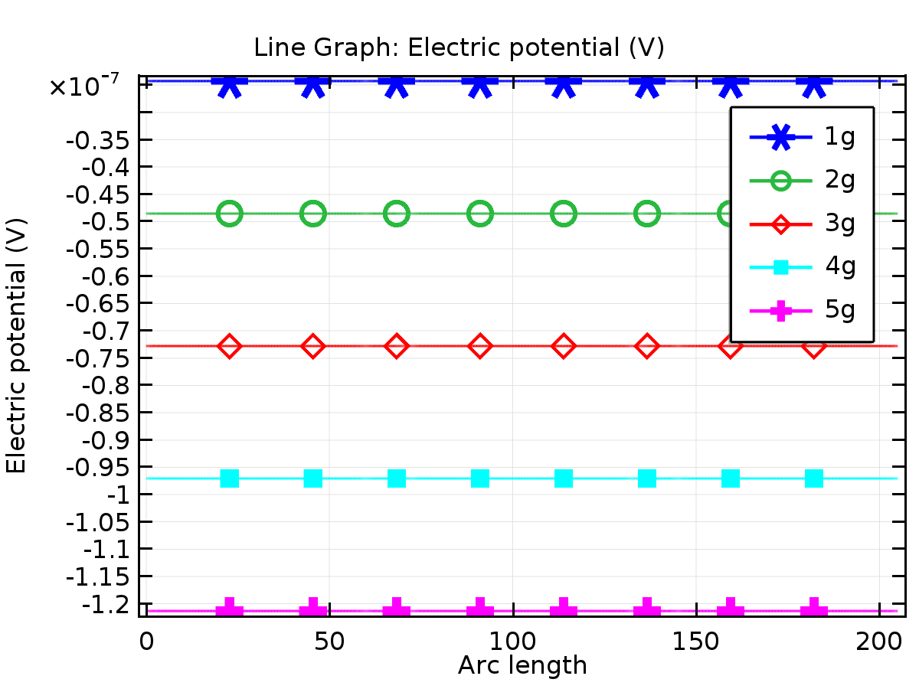

Line Graph: Electric potential (V)

* + 1. energy

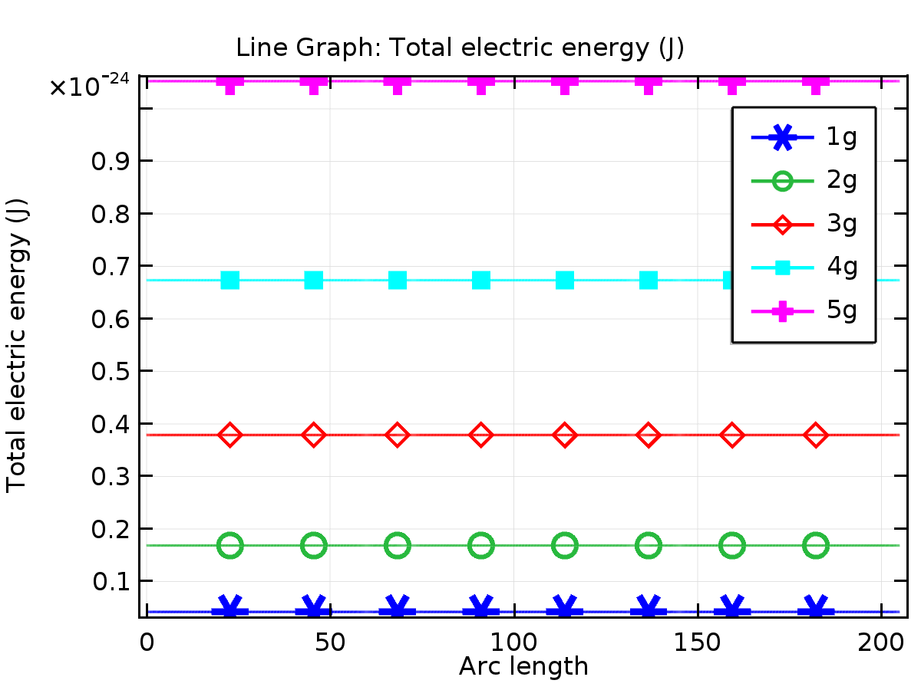

Line Graph: Total electric energy (J)